Exercise 1: Control Structures

Scenario 1: The bank wants to apply a discount to loan interest rates for customers above 60 years old.
Question: Write a PL/SQL block that loops through all customers, checks their age, and if they are above 60, apply a 1% discount to their current loan interest rates.

PL/SQL Block to Apply 1% Discount:
BEGIN
FOR rec IN (
SELECT c.customer_id, l.loan_id, l.interest_rate, c.age
FROM customers c JOIN loans l ON c.customer_id = l.customer_id
)
LOOP
IF rec.age > 60 THEN
UPDATE loans
SET interest_rate = interest_rate - 1
WHERE loan_id = rec.loan_id;
END IF;
END LOOP;
COMMIT;
END;
/

Display Output:
SELECT * FROM loans;

OUTPUT SCREENSHOTS:

VIEW OF CREATED TABLES:
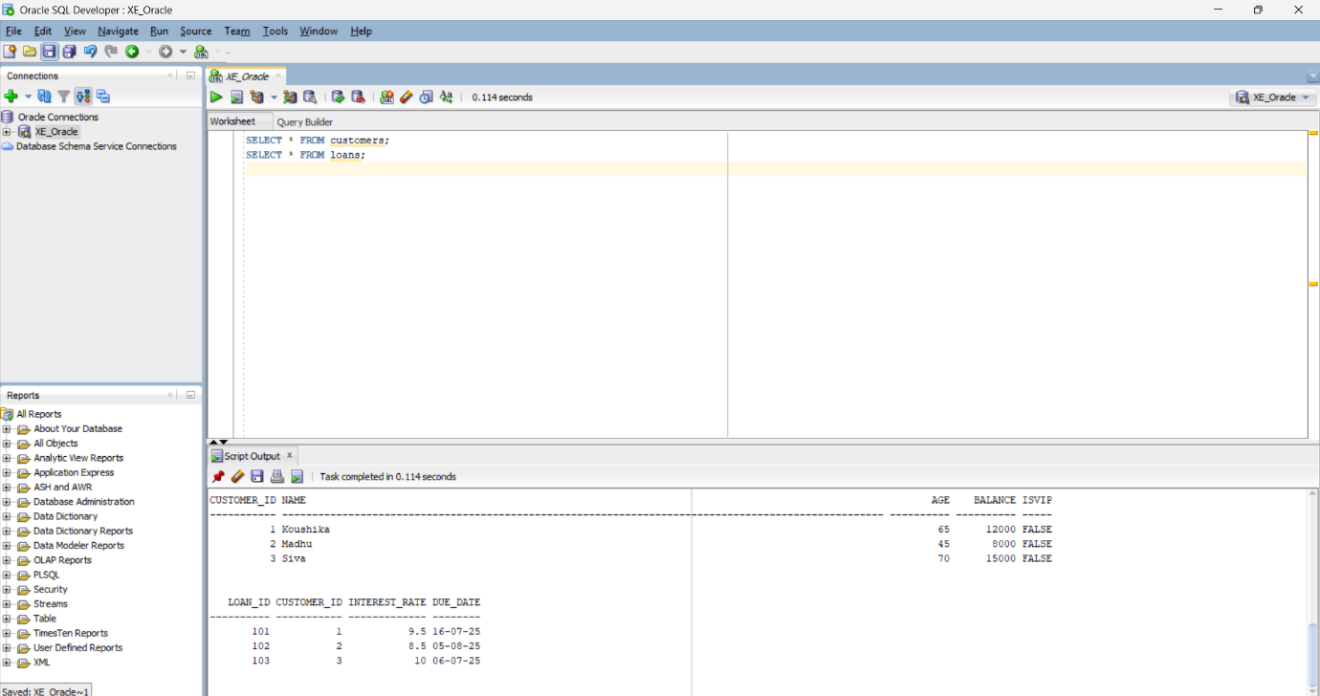
PL/SQL BLOCK :
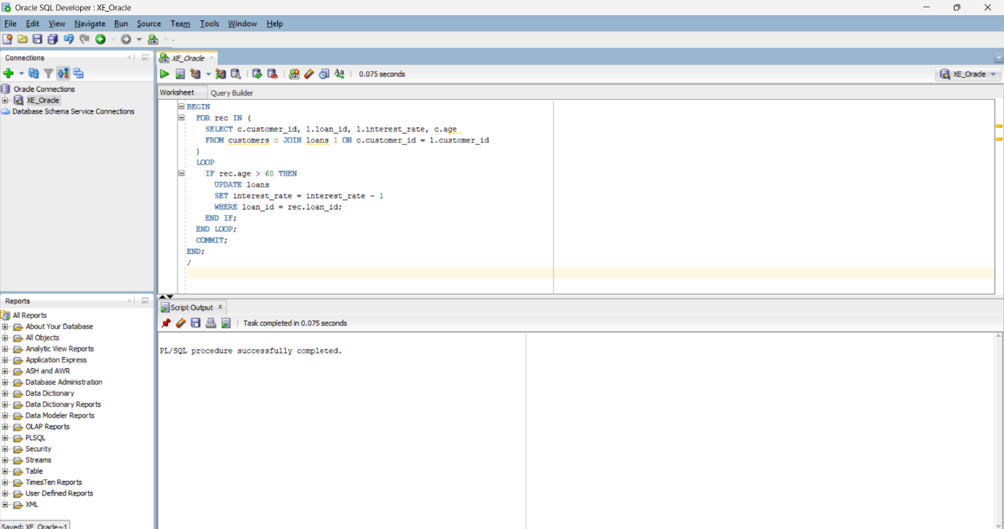
OUTPUT AFTER EXECUTION OF PL/SQL BLOCK:
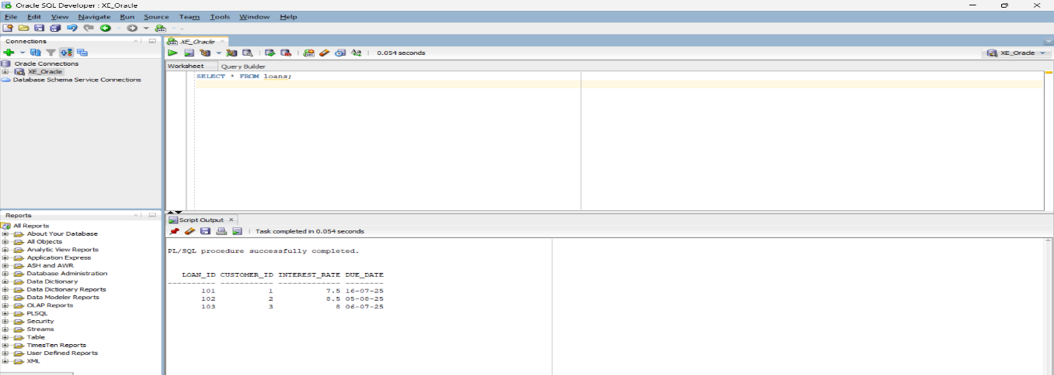

Scenario 2: A customer can be promoted to VIP status based on their balance.
Question: Write a PL/SQL block that iterates through all customers and sets a flag IsVIP to TRUE for those with a balance over $10,000.

PL/SQL Block to Set VIP Status:
BEGIN
FOR rec IN (SELECT customer_id, balance FROM customers)
LOOP
IF rec.balance > 10000 THEN
UPDATE customers
SET IsVIP = 'TRUE'
WHERE customer_id = rec.customer_id;
END IF;
END LOOP;
COMMIT;
END;
/
View Final Table with Updated VIP Flags:
SELECT * FROM customers;

OUTPUT SCREENSHOTS:
CREATION OF TABLE AND INSERTION OF VALUES:
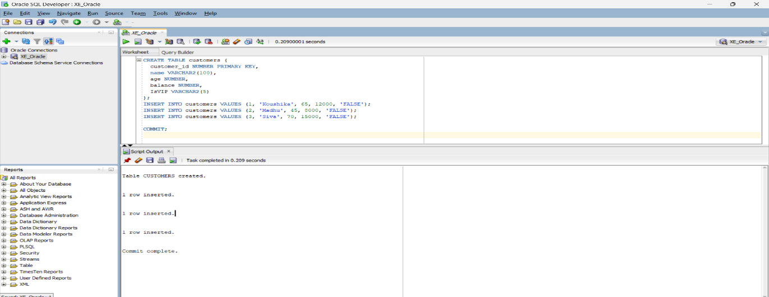
PL/SQL BLOCK:
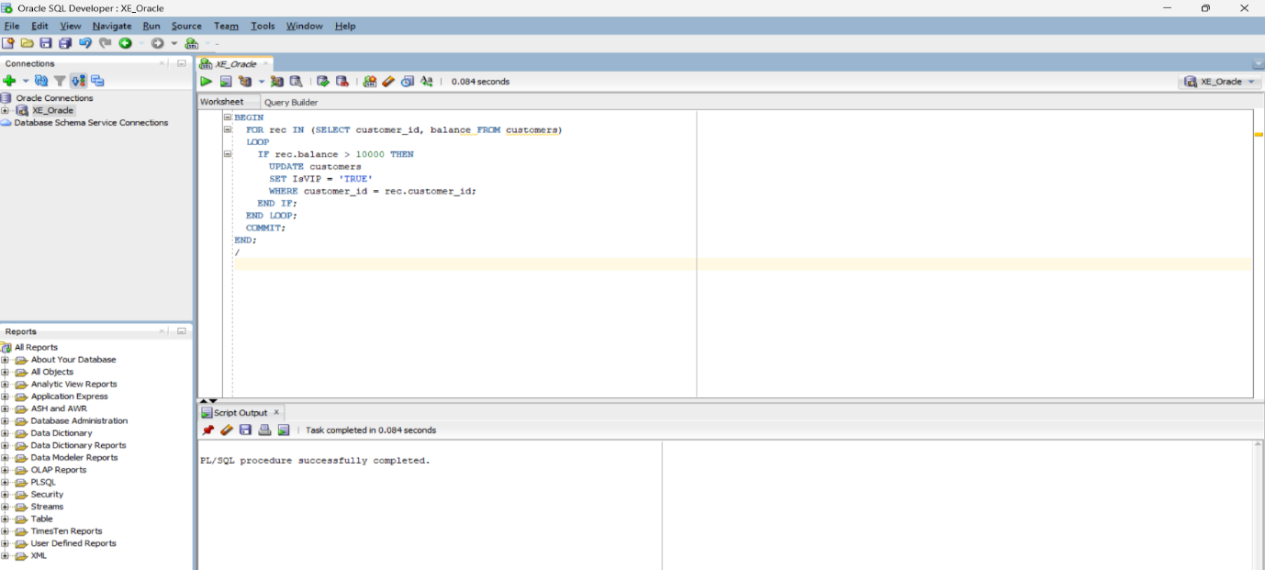
OUTPUT AFTER EXECUTION OF PL/SQL BLOCK:
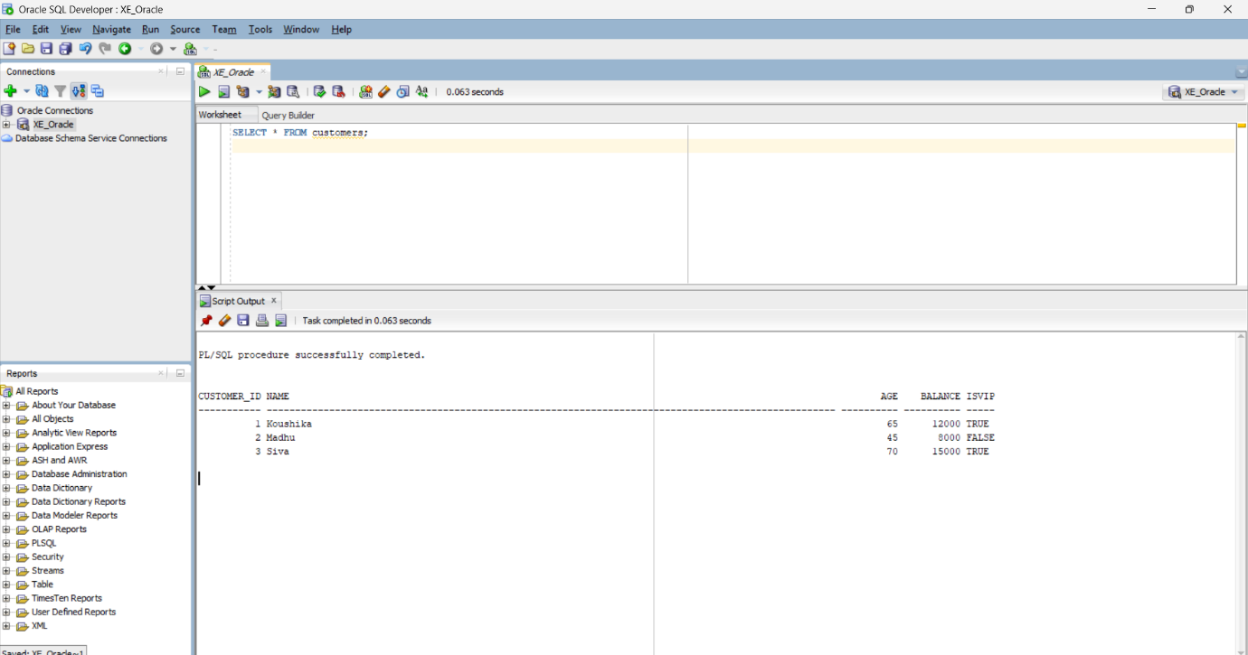

Scenario 3: The bank wants to send reminders to customers whose loans are due within the next 30 days.
Question: Write a PL/SQL block that fetches all loans due in the next 30 days and prints a reminder message for each customer.

PL/SQL Block to Print Reminders for Loans Due in Next 30 Days:
BEGIN
FOR rec IN (
SELECT l.loan_id, c.name, l.due_date
FROM loans l
JOIN customers c ON l.customer_id = c.customer_id
WHERE l.due_date BETWEEN SYSDATE AND SYSDATE + 30
)
LOOP
DBMS_OUTPUT.PUT_LINE(
'Reminder: Loan ' || rec.loan_id ||
' for customer ' || rec.name ||
' is due on ' || TO_CHAR(rec.due_date, 'DD-Mon-YYYY')
);
END LOOP;
END;
/

View All Loan Records:

SELECT * FROM loans;

OUTPUT :

CREATION OF TABLE AND INSERTION OF VALUES:
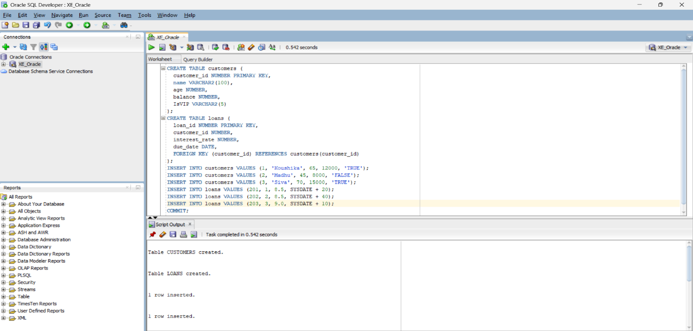
PL/SQL BLOCK:
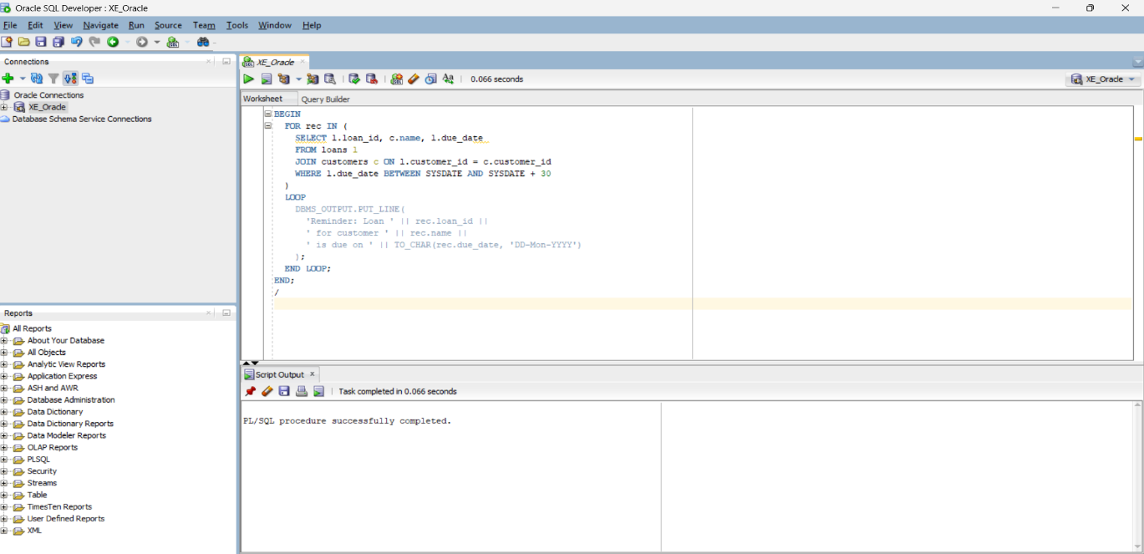
OUTPUT AFTER EXECUTION OF PL/SQL BLOCK:
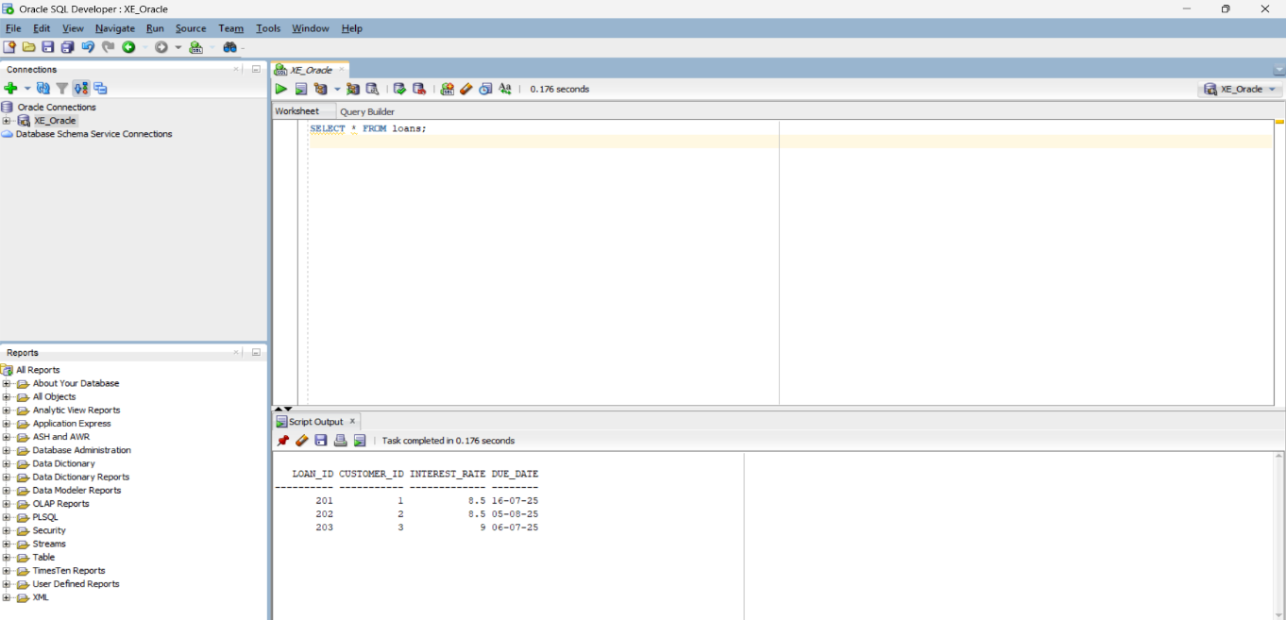

Exercise 2: Error Handling

Scenario 1: Handle exceptions during fund transfers between accounts.
Question: Write a stored procedure SafeTransferFunds that transfers funds between two accounts. Ensure that if any error occurs (e.g., insufficient funds), an appropriate error message is logged and the transaction is rolled back.
Create Customers Table
-- Recreate table
CREATE TABLE accounts (
acc_no NUMBER PRIMARY KEY,
holder_name VARCHAR2(100),
balance NUMBER
);

-- Insert fresh data
INSERT INTO accounts VALUES (101, 'Koushika', 5000);
INSERT INTO accounts VALUES (102, 'Madhu', 3000);
COMMIT;

PL/SQL code;
CREATE OR REPLACE PROCEDURE AddNewCustomer(
id IN NUMBER,
cname IN VARCHAR2,
cage IN NUMBER,
cbalance IN NUMBER
) IS
BEGIN
INSERT INTO customers(customer_id, name, age, balance, IsVIP)
VALUES (id, cname, cage, cbalance, 'FALSE');

COMMIT;
DBMS_OUTPUT.PUT_LINE('Customer added successfully.');

EXCEPTION
WHEN DUP_VAL_ON_INDEX THEN
DBMS_OUTPUT.PUT_LINE('Error: Customer ID already exists.');
WHEN OTHERS THEN
DBMS_OUTPUT.PUT_LINE('Insertion failed: ' || SQLERRM);
END;
/

TABLE CREATION

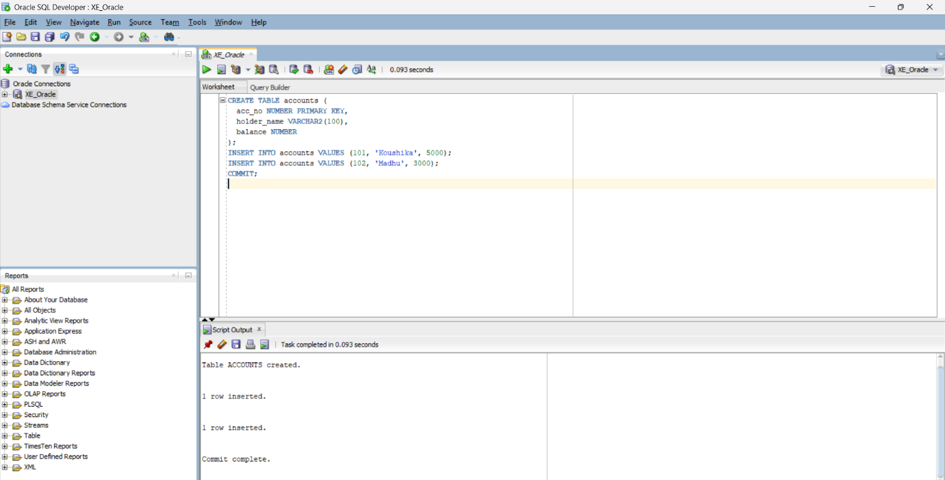
PLSQL
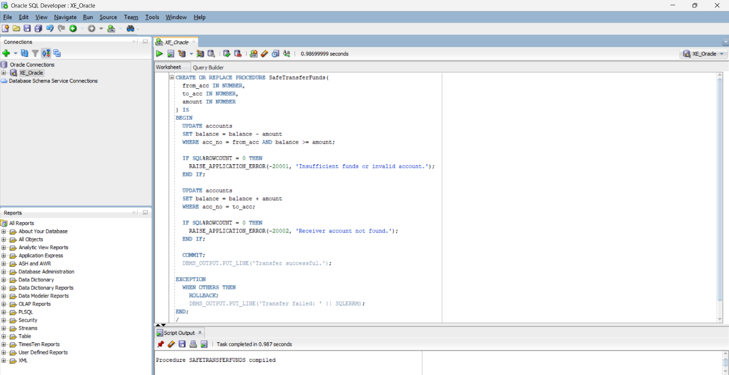
OUTPUT

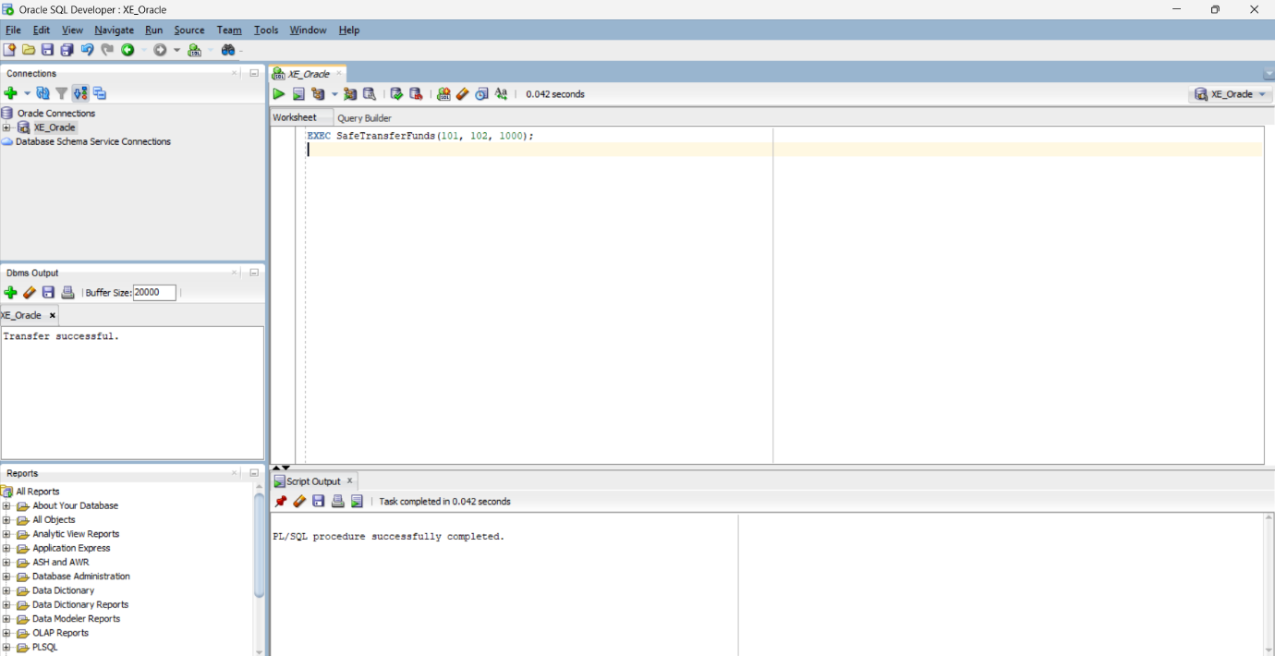

Scenario 2: Manage errors when updating employee salaries.
Question: Write a stored procedure UpdateSalary that increases the salary of an employee by a given percentage. If the employee ID does not exist, handle the exception and log an error message.

CREATE TABLE employees (
emp_id NUMBER PRIMARY KEY,
emp_name VARCHAR2(100),
salary NUMBER
);
INSERT INTO employees VALUES (201, 'Siva', 40000);
COMMIT;
CREATE OR REPLACE PROCEDURE UpdateSalary(
emp_id_in IN NUMBER,
percent IN NUMBER
) IS
BEGIN
UPDATE employees
SET salary = salary + (salary * percent / 100)
WHERE emp_id = emp_id_in;

IF SQL%ROWCOUNT = 0 THEN
RAISE_APPLICATION_ERROR(-20003, 'Employee ID not found.');
END IF;

COMMIT;
DBMS_OUTPUT.PUT_LINE('Salary updated successfully.');

EXCEPTION
WHEN OTHERS THEN
ROLLBACK;
DBMS_OUTPUT.PUT_LINE('Salary update failed: ' || SQLERRM);
END;
/
EXEC UpdateSalary(201, 10);

TABLE CREATION
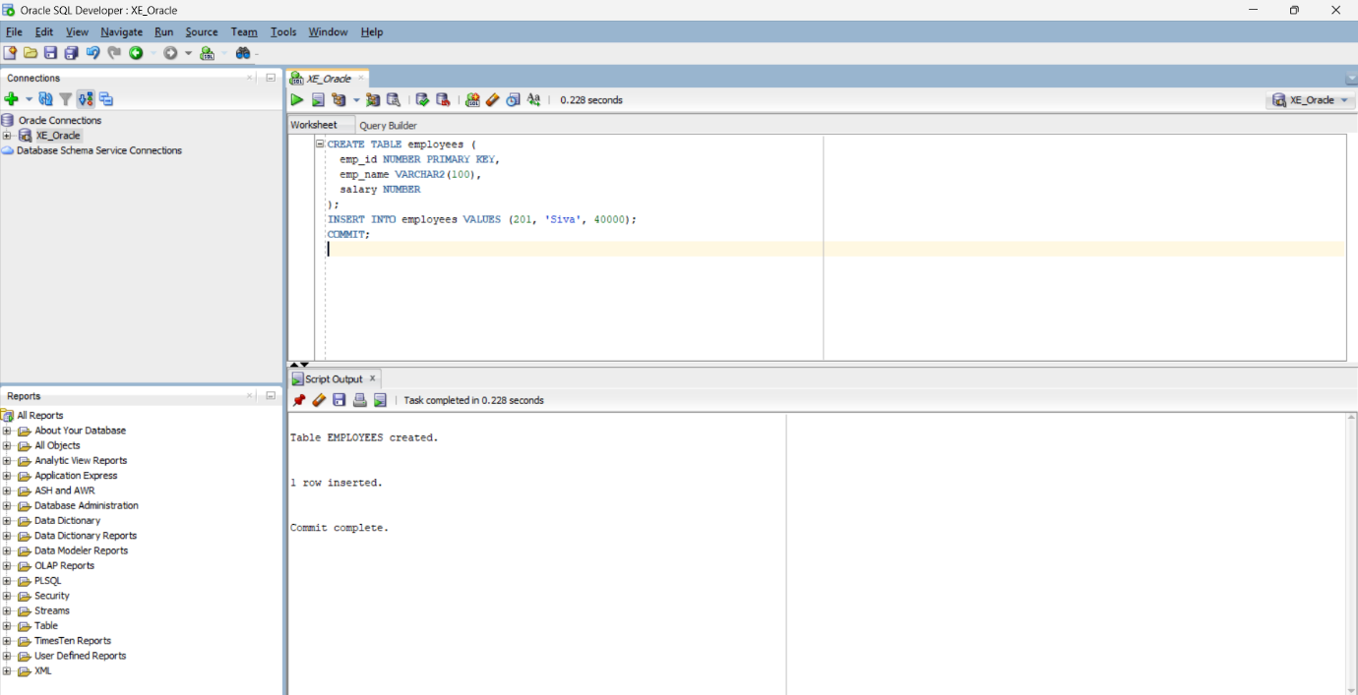
PLSQL
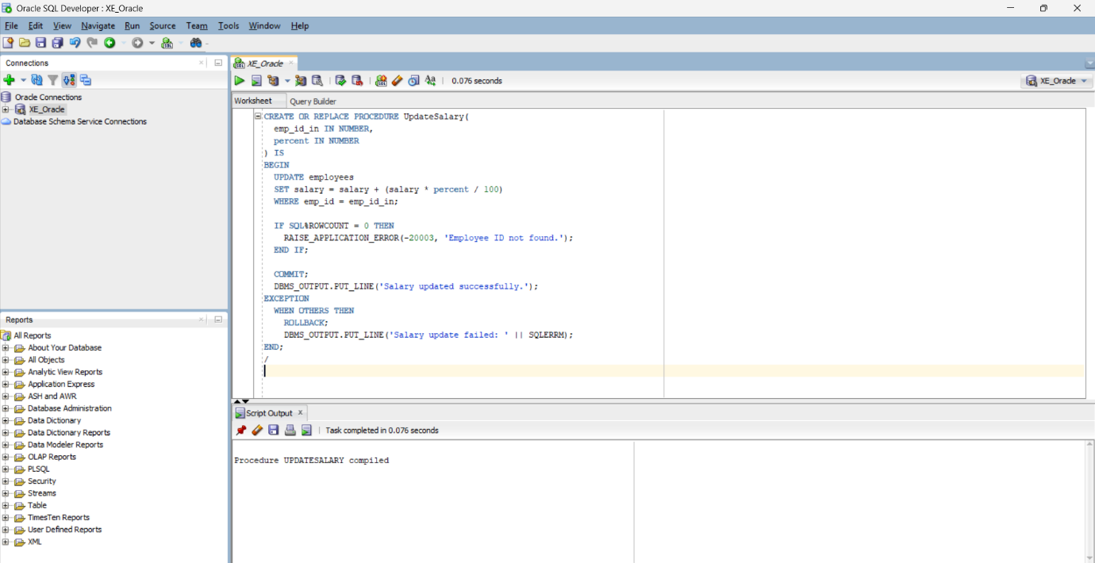
OUTPUT

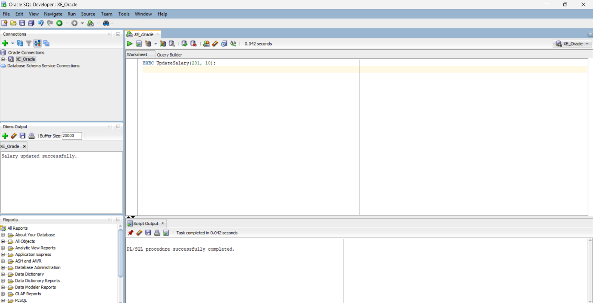

Scenario 3: Ensure data integrity when adding a new customer.
  - Question: Write a stored procedure AddNewCustomer that inserts a new customer into the Customers table. If a customer with the same ID already exists, handle the exception by logging an error and preventing the insertion.
CREATE TABLE customers (
customer_id NUMBER PRIMARY KEY,
name VARCHAR2(100),
age NUMBER,
balance NUMBER,
IsVIP VARCHAR2(5)
);
CREATE OR REPLACE PROCEDURE AddNewCustomer(
id IN NUMBER,
cname IN VARCHAR2,
cage IN NUMBER,
cbalance IN NUMBER
) IS
BEGIN
INSERT INTO customers(customer_id, name, age, balance, IsVIP)
VALUES (id, cname, cage, cbalance, 'FALSE');

COMMIT;
DBMS_OUTPUT.PUT_LINE('Customer added successfully.');

EXCEPTION
WHEN DUP_VAL_ON_INDEX THEN
DBMS_OUTPUT.PUT_LINE('Error: Customer ID already exists.');
WHEN OTHERS THEN
DBMS_OUTPUT.PUT_LINE('Insertion failed: ' || SQLERRM);
END;
/
EXEC AddNewCustomer(1, 'Ajay', 35, 7000);
TABLE CREATION
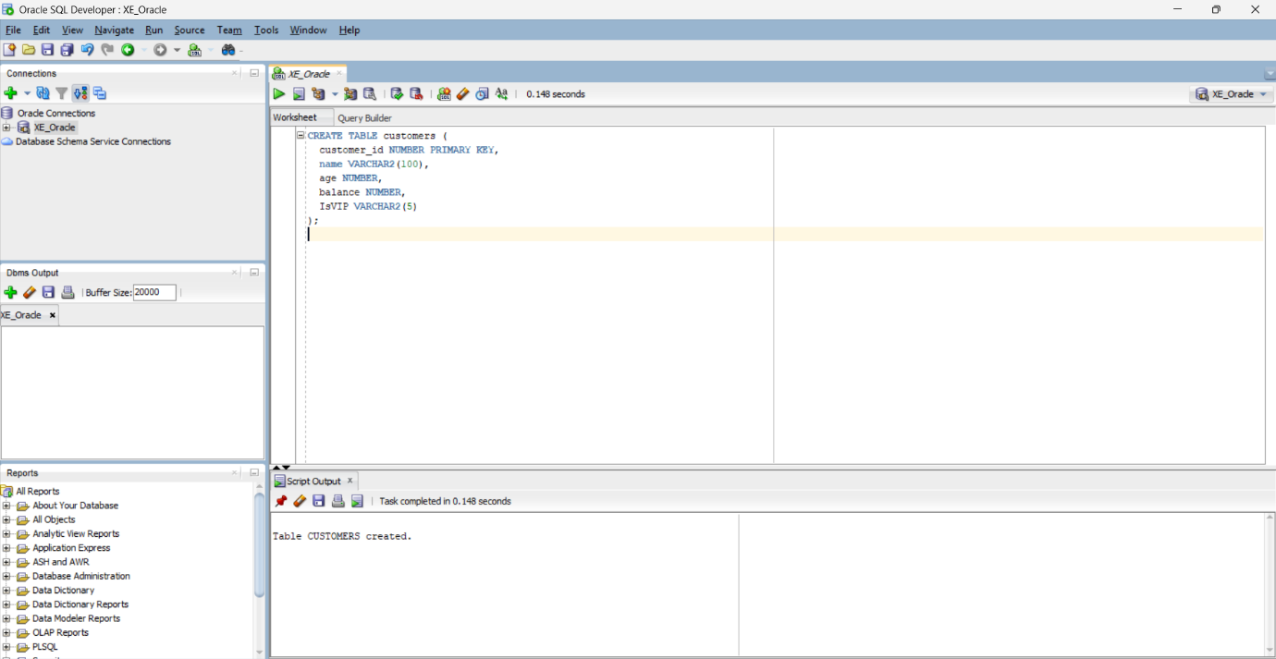
PLSQL
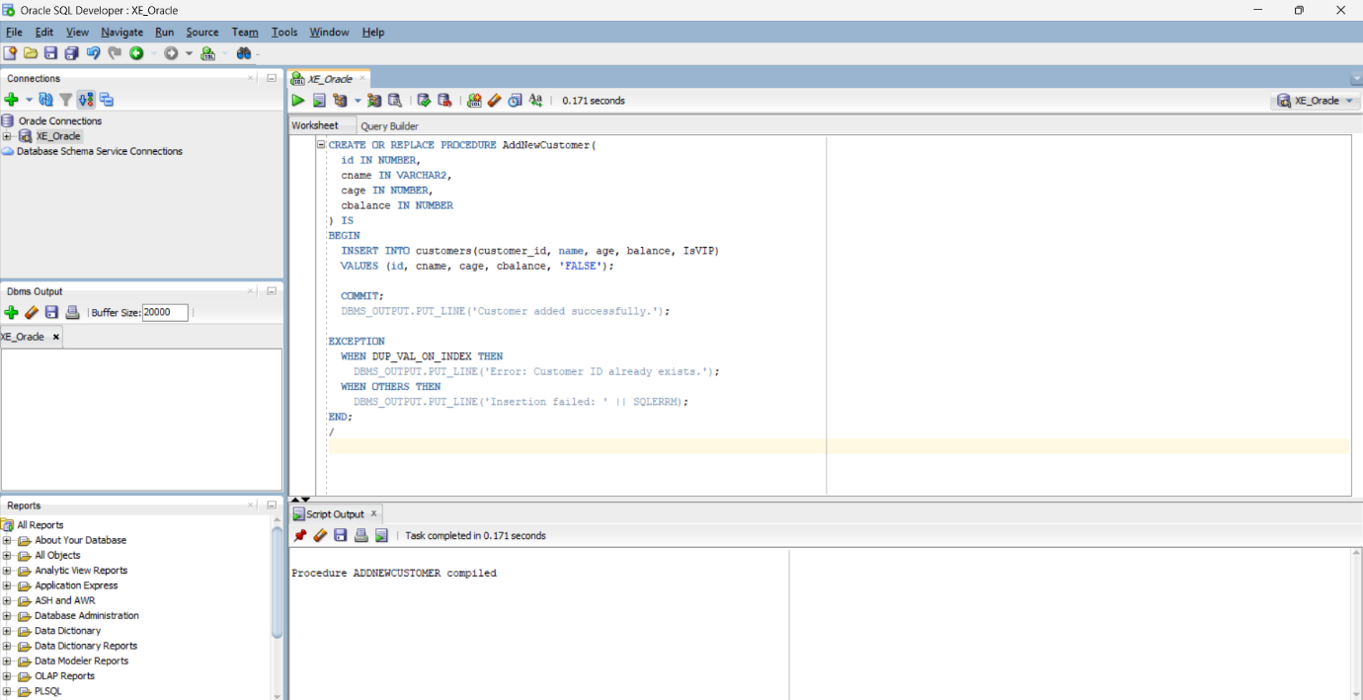
OUTPUT
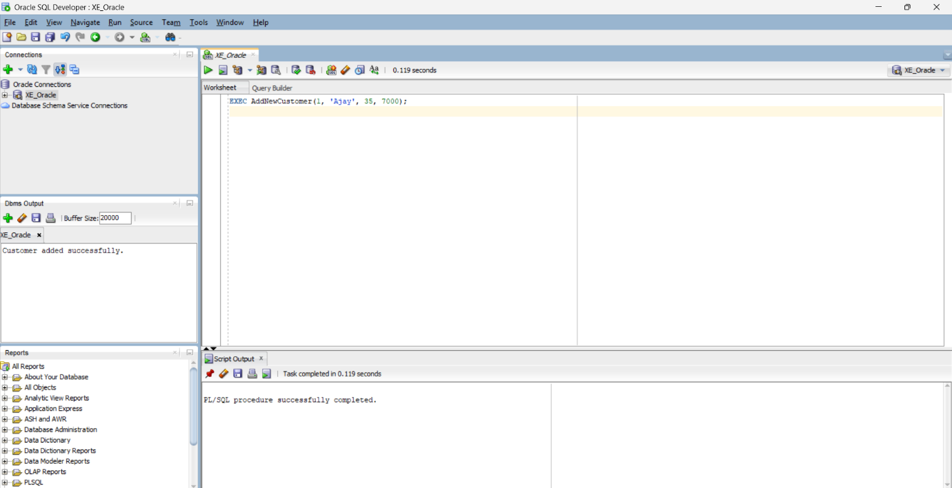

Exercise 3: Stored Procedures

Scenario 1: The bank needs to process monthly interest for all savings accounts.
Question: Write a stored procedure ProcessMonthlyInterest that calculates and updates the balance of all savings accounts by applying an interest rate of 1% to the current balance.

CREATE TABLE savings_accounts (
acc_no NUMBER PRIMARY KEY,
holder_name VARCHAR2(100),
balance NUMBER
);
INSERT INTO savings_accounts VALUES (201, 'Koushika', 10000);
INSERT INTO savings_accounts VALUES (202, 'Madhu', 15000);
COMMIT;
CREATE OR REPLACE PROCEDURE ProcessMonthlyInterest IS
BEGIN
UPDATE savings_accounts
SET balance = balance + (balance * 0.01);
COMMIT;
DBMS_OUTPUT.PUT_LINE('Monthly interest applied successfully.');
END;
/
EXEC ProcessMonthlyInterest;

OUTPUT:
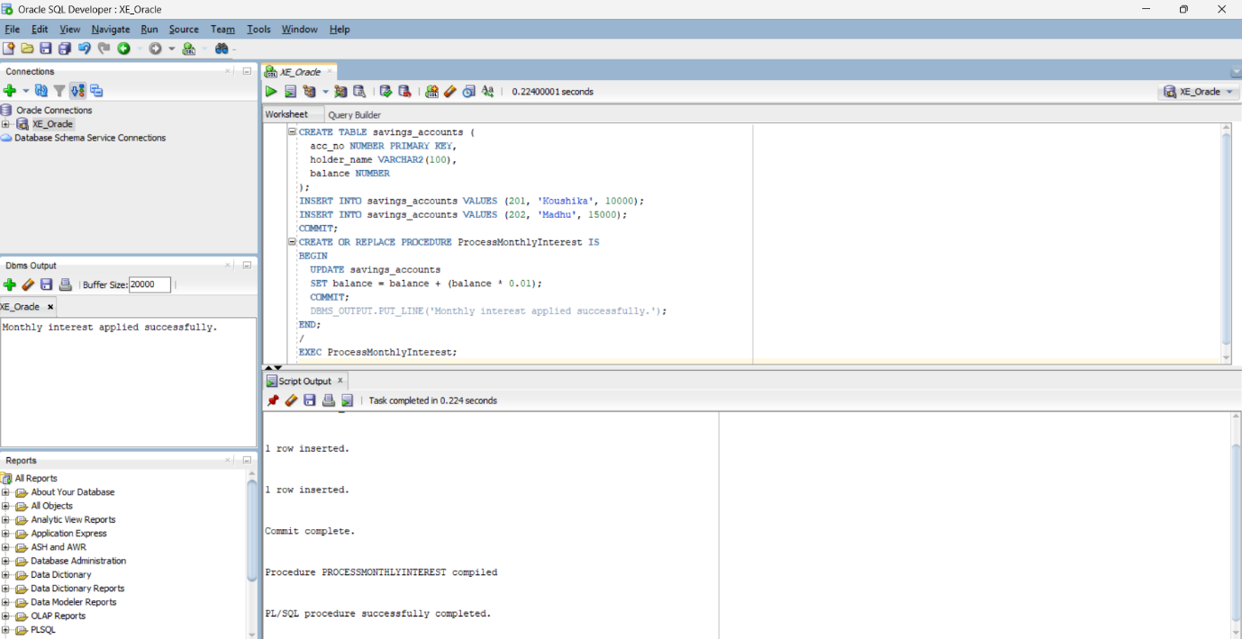

Scenario 2: The bank wants to implement a bonus scheme for employees based on their performance.
Question: Write a stored procedure UpdateEmployeeBonus that updates the salary of employees in a given department by adding a bonus percentage passed as a parameter.
CREATE TABLE employees (
emp_id NUMBER PRIMARY KEY,
emp_name VARCHAR2(100),
department VARCHAR2(50),
salary NUMBER
);
INSERT INTO employees VALUES (301, 'Siva', 'IT', 50000);
INSERT INTO employees VALUES (302, 'Arun', 'HR', 40000);
INSERT INTO employees VALUES (303, 'Meena', 'IT', 55000);
COMMIT;
CREATE OR REPLACE PROCEDURE UpdateEmployeeBonus(
dept_name IN VARCHAR2,
bonus_percent IN NUMBER
) IS
BEGIN
UPDATE employees
SET salary = salary + (salary * bonus_percent / 100)
WHERE department = dept_name;

COMMIT;
DBMS_OUTPUT.PUT_LINE('Bonus applied to ' || dept_name || ' department.');
END;
/
EXEC UpdateEmployeeBonus('IT', 10);
OUTPUT:
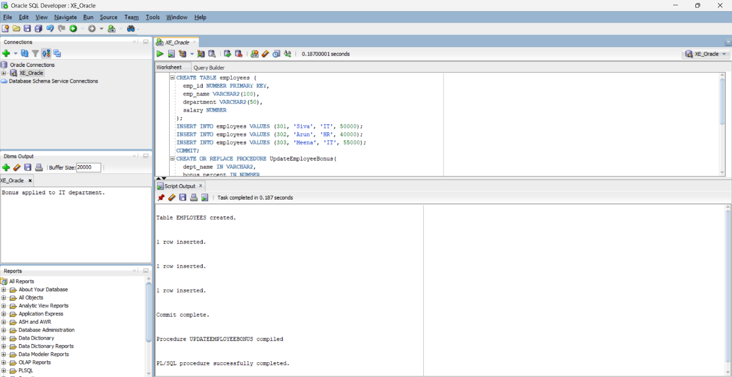
Scenario 3: Customers should be able to transfer funds between their accounts.
Question: Write a stored procedure TransferFunds that transfers a specified amount from one account to another, checking that the source account has sufficient balance before making the transfer.
CREATE TABLE accounts (
acc_no NUMBER PRIMARY KEY,
holder_name VARCHAR2(100),
balance NUMBER
);
INSERT INTO accounts VALUES (401, 'Koushika', 8000);
INSERT INTO accounts VALUES (402, 'Madhu', 3000);
COMMIT;
CREATE OR REPLACE PROCEDURE TransferFunds(
from_acc IN NUMBER,
to_acc IN NUMBER,
amount IN NUMBER
) IS
BEGIN
UPDATE accounts
SET balance = balance - amount
WHERE acc_no = from_acc AND balance >= amount;

IF SQL%ROWCOUNT = 0 THEN
RAISE_APPLICATION_ERROR(-20001, 'Insufficient balance or invalid source account.');
END IF;

UPDATE accounts
SET balance = balance + amount
WHERE acc_no = to_acc;

IF SQL%ROWCOUNT = 0 THEN
RAISE_APPLICATION_ERROR(-20002, 'Invalid destination account.');
END IF;

COMMIT;
DBMS_OUTPUT.PUT_LINE('Transfer completed successfully.');
EXCEPTION
WHEN OTHERS THEN
ROLLBACK;
DBMS_OUTPUT.PUT_LINE('Transfer failed: ' || SQLERRM);
END;
/

EXEC TransferFunds(401, 402, 1000);
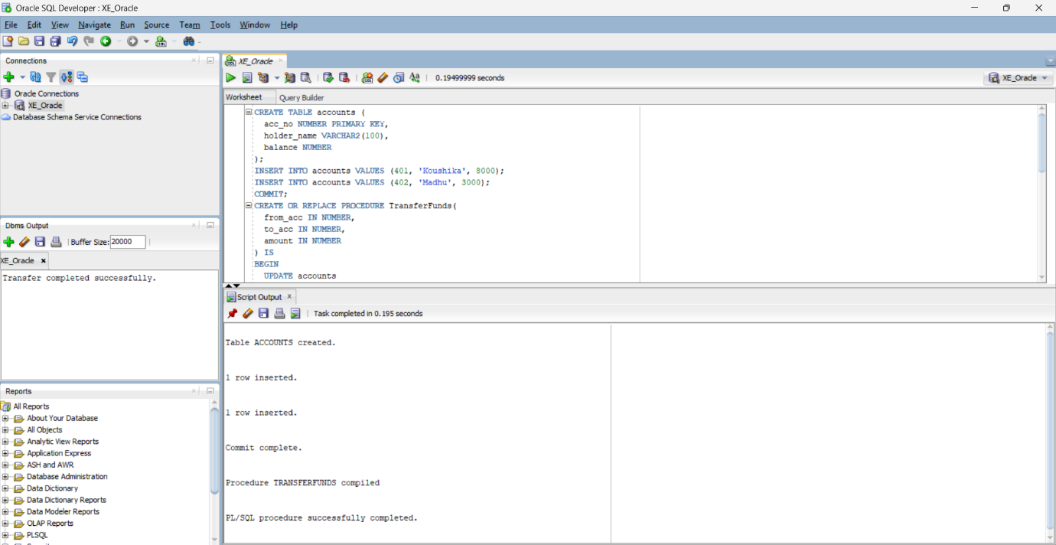
OUTPUT:
Exercise 4: Functions

Scenario 1: Calculate the age of customers for eligibility checks.
Question: Write a function CalculateAge that takes a customer's date of birth as input and returns their age in years.
CREATE OR REPLACE FUNCTION CalculateAge(dob DATE)
RETURN NUMBER IS
age NUMBER;
BEGIN
age := FLOOR(MONTHS_BETWEEN(SYSDATE, dob) / 12);
RETURN age;
END;
/
--example
SELECT CalculateAge(TO_DATE('2000-01-15', 'YYYY-MM-DD')) AS age FROM dual;
OUTPUT:
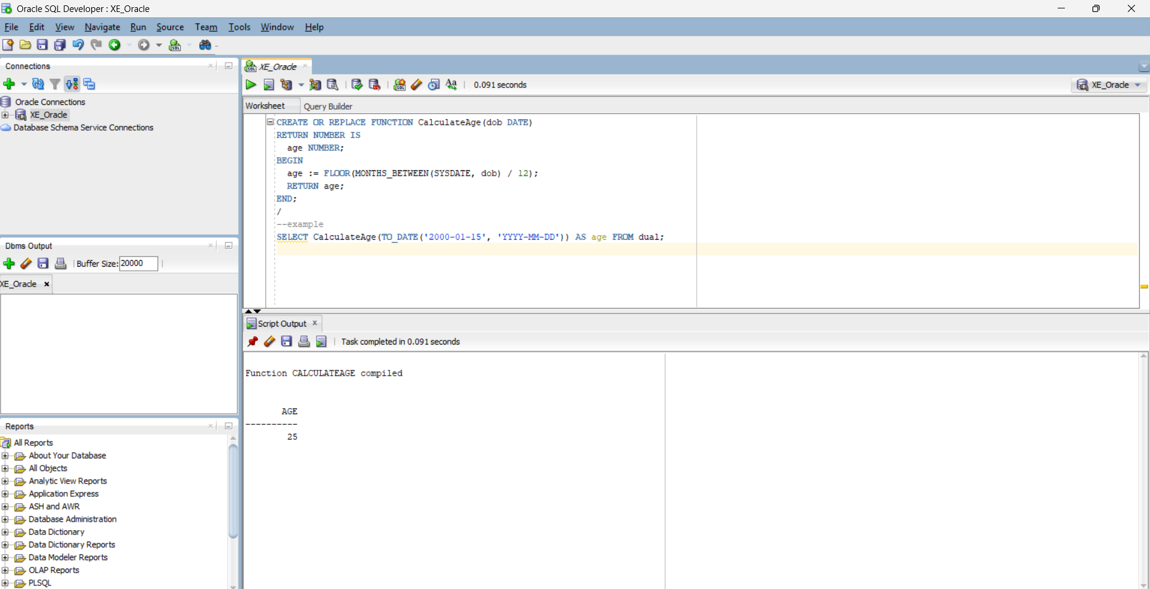

Scenario 2: The bank needs to compute the monthly installment for a loan.
Question: Write a function CalculateMonthlyInstallment that takes the loan amount, interest rate, and loan duration in years as input and returns the monthly installment amount.
CREATE OR REPLACE FUNCTION CalculateMonthlyInstallment(
amount NUMBER,
annual_rate NUMBER,
years NUMBER
)
RETURN NUMBER IS
monthly_rate NUMBER;
n NUMBER;
emi NUMBER;
BEGIN
monthly_rate := annual_rate / 12 / 100;
n := years * 12;
emi := (amount * monthly_rate * POWER(1 + monthly_rate, n)) /
(POWER(1 + monthly_rate, n) - 1);
RETURN ROUND(emi, 2);
END;
/
--example
SELECT CalculateMonthlyInstallment(100000, 10, 2) AS emi FROM dual;
OUTPUT:

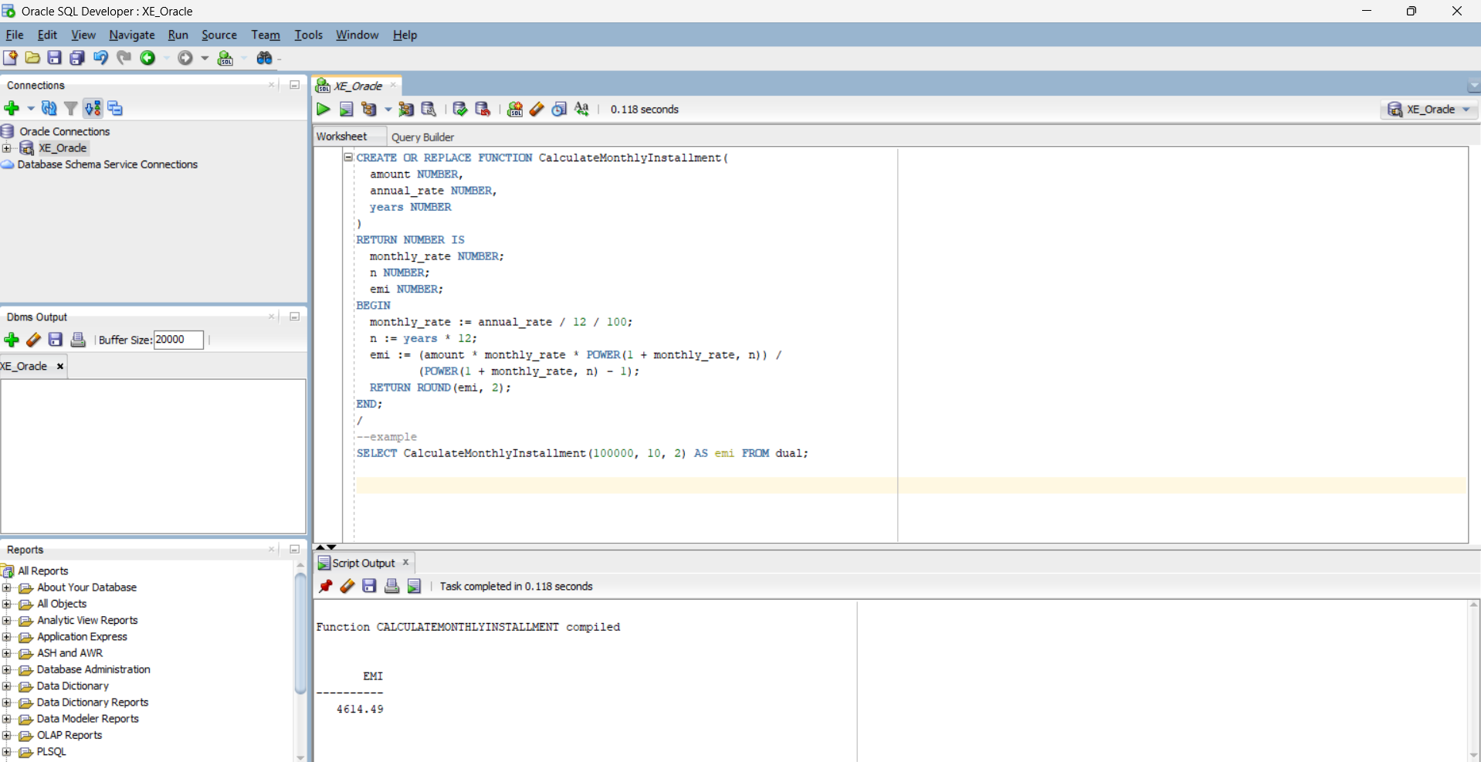

Scenario 3: Check if a customer has sufficient balance before making a transaction.
Question: Write a function HasSufficientBalance that takes an account ID and an amount as input and returns a boolean indicating whether the account has at least the specified amount.
CREATE TABLE accounts (
acc_no NUMBER PRIMARY KEY,
holder_name VARCHAR2(100),
balance NUMBER
);
CREATE OR REPLACE FUNCTION HasSufficientBalance(
acc_id IN NUMBER,
amount IN NUMBER
)
RETURN BOOLEAN IS
acc_balance NUMBER;
BEGIN
SELECT balance INTO acc_balance FROM accounts WHERE acc_no = acc_id;
RETURN acc_balance >= amount;
EXCEPTION
WHEN NO_DATA_FOUND THEN
RETURN FALSE;
END;
/
--example usage
DECLARE
result BOOLEAN;
BEGIN
result := HasSufficientBalance(401, 2000);
IF result THEN
DBMS_OUTPUT.PUT_LINE('Sufficient balance.');
ELSE
DBMS_OUTPUT.PUT_LINE('Insufficient balance.');
END IF;
END;

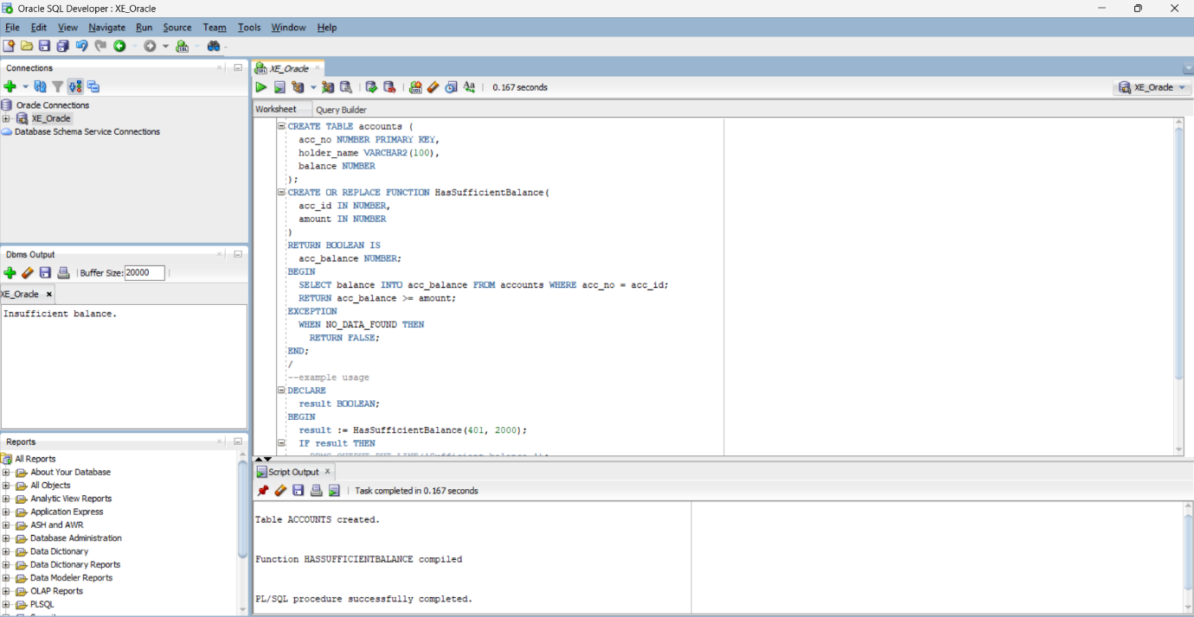
OUTPUT:

Exercise 5: Triggers

Scenario 1: Automatically update the last modified date when a customer's record is updated.
Question: Write a trigger UpdateCustomerLastModified that updates the LastModified column of the Customers table to the current date whenever a customer's record is updated.
CREATE TABLE customers (
customer_id NUMBER PRIMARY KEY,
name VARCHAR2(100),
age NUMBER,
balance NUMBER,
IsVIP VARCHAR2(5),
LastModified DATE
);
INSERT INTO customers VALUES (1, 'Koushika', 25, 12000, 'FALSE', SYSDATE);
COMMIT;
CREATE OR REPLACE TRIGGER UpdateCustomerLastModified
BEFORE UPDATE ON customers
FOR EACH ROW
BEGIN
:NEW.LastModified := SYSDATE;
END;
/
--example usage
UPDATE customers SET balance = balance + 1000 WHERE customer_id = 1;
SELECT * FROM customers WHERE customer_id = 1;

OUTPUT:
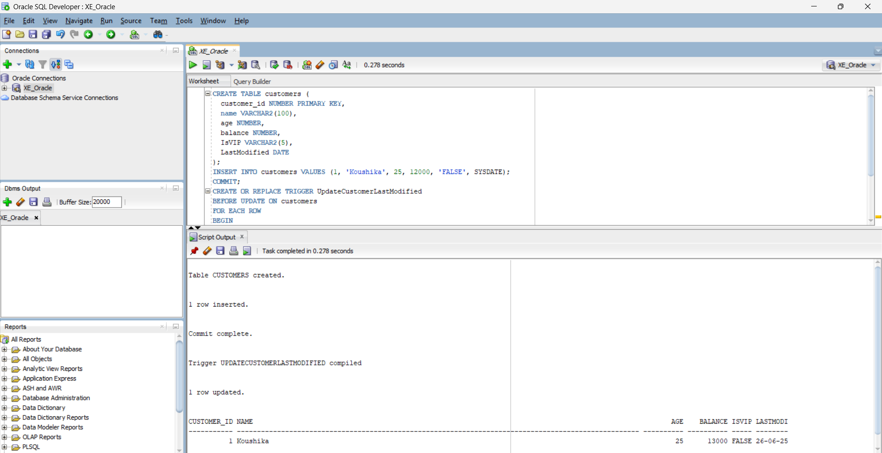

Scenario 2: Maintain an audit log for all transactions.
Question: Write a trigger LogTransaction that inserts a record into an AuditLog table whenever a transaction is inserted into the Transactions table.
CREATE TABLE transactions (
txn_id NUMBER PRIMARY KEY,
acc_no NUMBER,
txn_type VARCHAR2(20),
amount NUMBER,
txn_date DATE
);
CREATE TABLE audit_log (
log_id NUMBER GENERATED ALWAYS AS IDENTITY PRIMARY KEY,
txn_id NUMBER,
log_time DATE,
action VARCHAR2(50)
);
CREATE OR REPLACE TRIGGER LogTransaction
AFTER INSERT ON transactions
FOR EACH ROW
BEGIN
INSERT INTO audit_log (txn_id, log_time, action)
VALUES (:NEW.txn_id, SYSDATE, 'Transaction Inserted');
END;
/
--example usage
INSERT INTO transactions VALUES (1001, 401, 'deposit', 2000, SYSDATE);
SELECT * FROM audit_log;

OUTPUT:
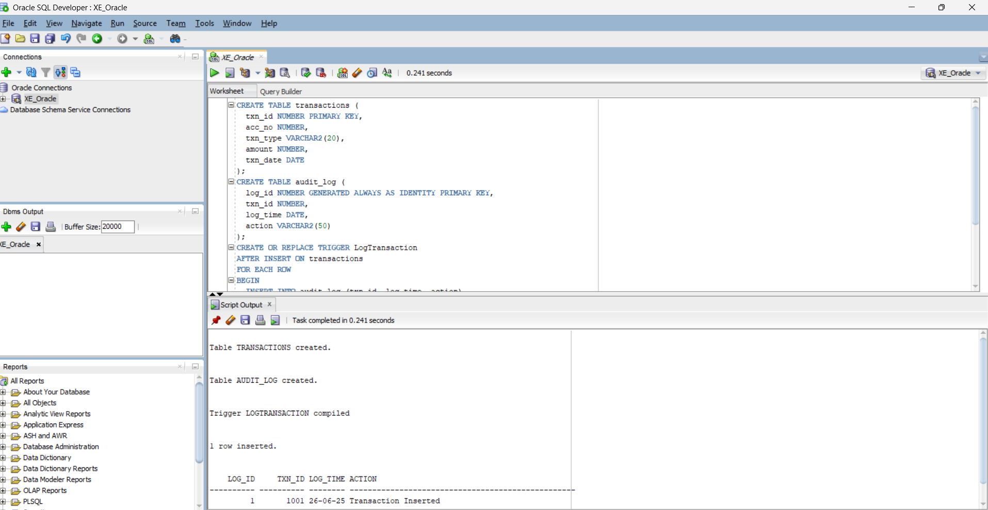

Scenario 3: Enforce business rules on deposits and withdrawals.
Question: Write a trigger CheckTransactionRules that ensures withdrawals do not exceed the balance and deposits are positive before inserting a record into the Transactions table.
CREATE TABLE accounts (
acc_no NUMBER PRIMARY KEY,
holder_name VARCHAR2(100),
balance NUMBER
);
CREATE TABLE transactions (
txn_id NUMBER PRIMARY KEY,
acc_no NUMBER,
txn_type VARCHAR2(20),
amount NUMBER,
txn_date DATE
);
INSERT INTO accounts VALUES (401, 'Koushika', 8000);
COMMIT;
CREATE OR REPLACE TRIGGER CheckTransactionRules
BEFORE INSERT ON transactions
FOR EACH ROW
DECLARE
acc_balance NUMBER;
BEGIN
SELECT balance INTO acc_balance
FROM accounts
WHERE acc_no = :NEW.acc_no;

IF :NEW.txn_type = 'withdraw' AND :NEW.amount > acc_balance THEN
RAISE_APPLICATION_ERROR(-20001, 'Withdrawal exceeds current balance.');
END IF;

IF :NEW.txn_type = 'deposit' AND :NEW.amount <= 0 THEN
RAISE_APPLICATION_ERROR(-20002, 'Deposit amount must be positive.');
END IF;

EXCEPTION
WHEN NO_DATA_FOUND THEN
RAISE_APPLICATION_ERROR(-20003, 'Account not found.');
END;
/
--example usage
INSERT INTO transactions VALUES (1001, 401, 'deposit', 1000, SYSDATE);
OUTPUT:
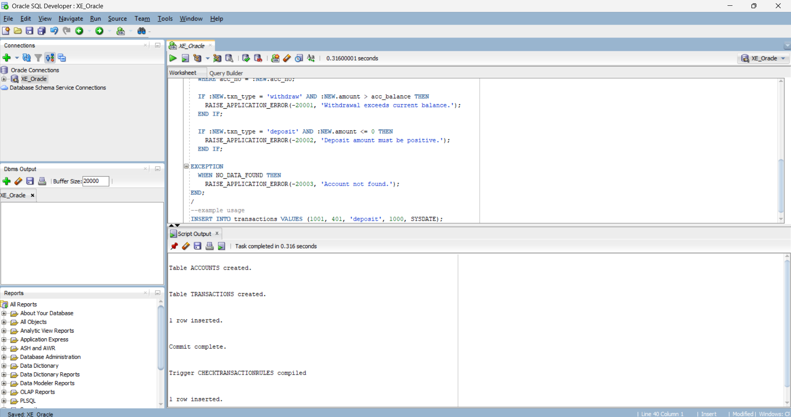

Exercise 6: Cursors

Scenario 1: Generate monthly statements for all customers.
Question: Write a PL/SQL block using an explicit cursor GenerateMonthlyStatements that retrieves all transactions for the current month and prints a statement for each customer.
CREATE TABLE transactions (
txn_id NUMBER PRIMARY KEY,
acc_no NUMBER,
txn_type VARCHAR2(20),
amount NUMBER,
txn_date DATE
);
INSERT INTO transactions VALUES (2001, 401, 'deposit', 1000, SYSDATE);
INSERT INTO transactions VALUES (2002, 401, 'withdraw', 500, SYSDATE - 2);
INSERT INTO transactions VALUES (2003, 402, 'deposit', 2000, SYSDATE - 40);
COMMIT;

DECLARE
CURSOR txn_cursor IS
SELECT acc_no, txn_type, amount, txn_date
FROM transactions
WHERE TO_CHAR(txn_date, 'MMYYYY') = TO_CHAR(SYSDATE, 'MMYYYY');

v_acc_no transactions.acc_no%TYPE;
v_type transactions.txn_type%TYPE;
v_amt transactions.amount%TYPE;
v_date transactions.txn_date%TYPE;
BEGIN
OPEN txn_cursor;
LOOP
FETCH txn_cursor INTO v_acc_no, v_type, v_amt, v_date;
EXIT WHEN txn_cursor%NOTFOUND;

DBMS_OUTPUT.PUT_LINE('Account: ' || v_acc_no || ' | Type: ' || v_type || ' | Amount: ' || v_amt || ' | Date: ' || TO_CHAR(v_date, 'DD-Mon-YYYY'));
END LOOP;
CLOSE txn_cursor;
END;
/
--example usage
SELECT * FROM transactions
WHERE TO_CHAR(txn_date, 'MMYYYY') = TO_CHAR(SYSDATE, 'MMYYYY');

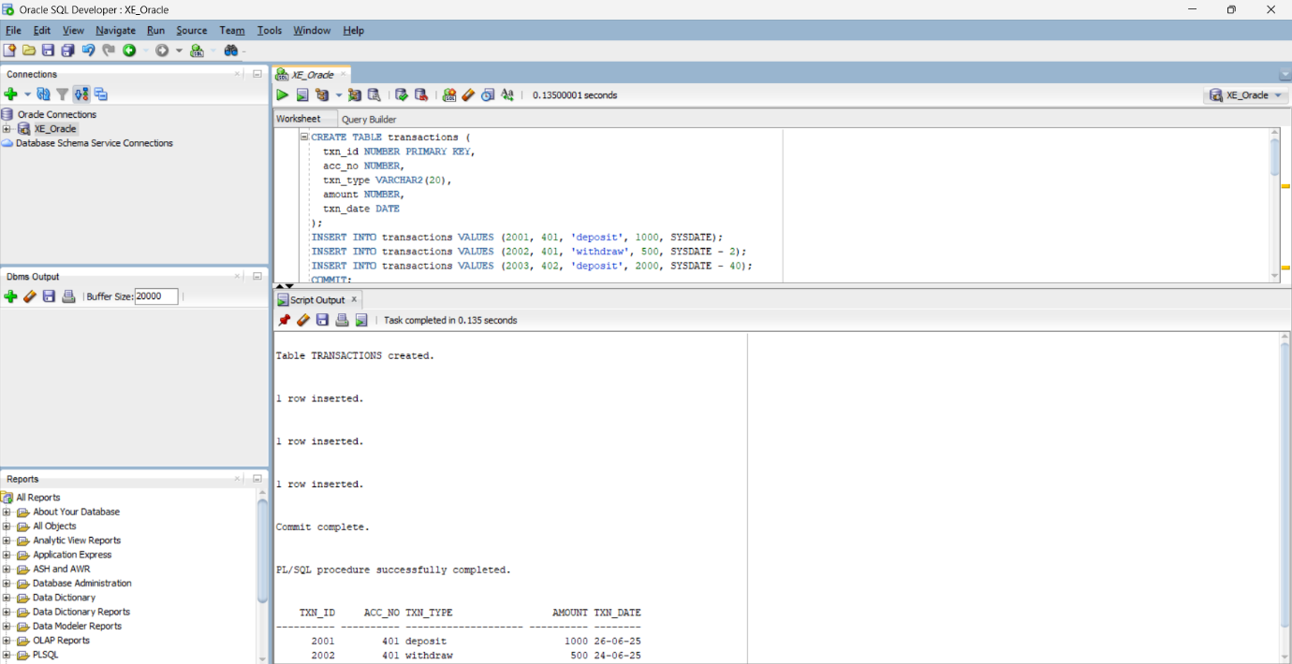
OUTPUT:

Scenario 2: Apply annual fee to all accounts.
Question: Write a PL/SQL block using an explicit cursor ApplyAnnualFee that deducts an annual maintenance fee from the balance of all accounts.

DECLARE
CURSOR acc_cursor IS
SELECT acc_no, balance FROM accounts;

v_acc_no accounts.acc_no%TYPE;
v_balance accounts.balance%TYPE;
annual_fee CONSTANT NUMBER := 500;
BEGIN
OPEN acc_cursor;
LOOP
FETCH acc_cursor INTO v_acc_no, v_balance;
EXIT WHEN acc_cursor%NOTFOUND;

UPDATE accounts
SET balance = balance - annual_fee
WHERE acc_no = v_acc_no;

DBMS_OUTPUT.PUT_LINE('Annual fee applied to Account: ' || v_acc_no);
END LOOP;
CLOSE acc_cursor;
COMMIT;
END;
/
--view
SELECT * FROM accounts;

OUTPUT:

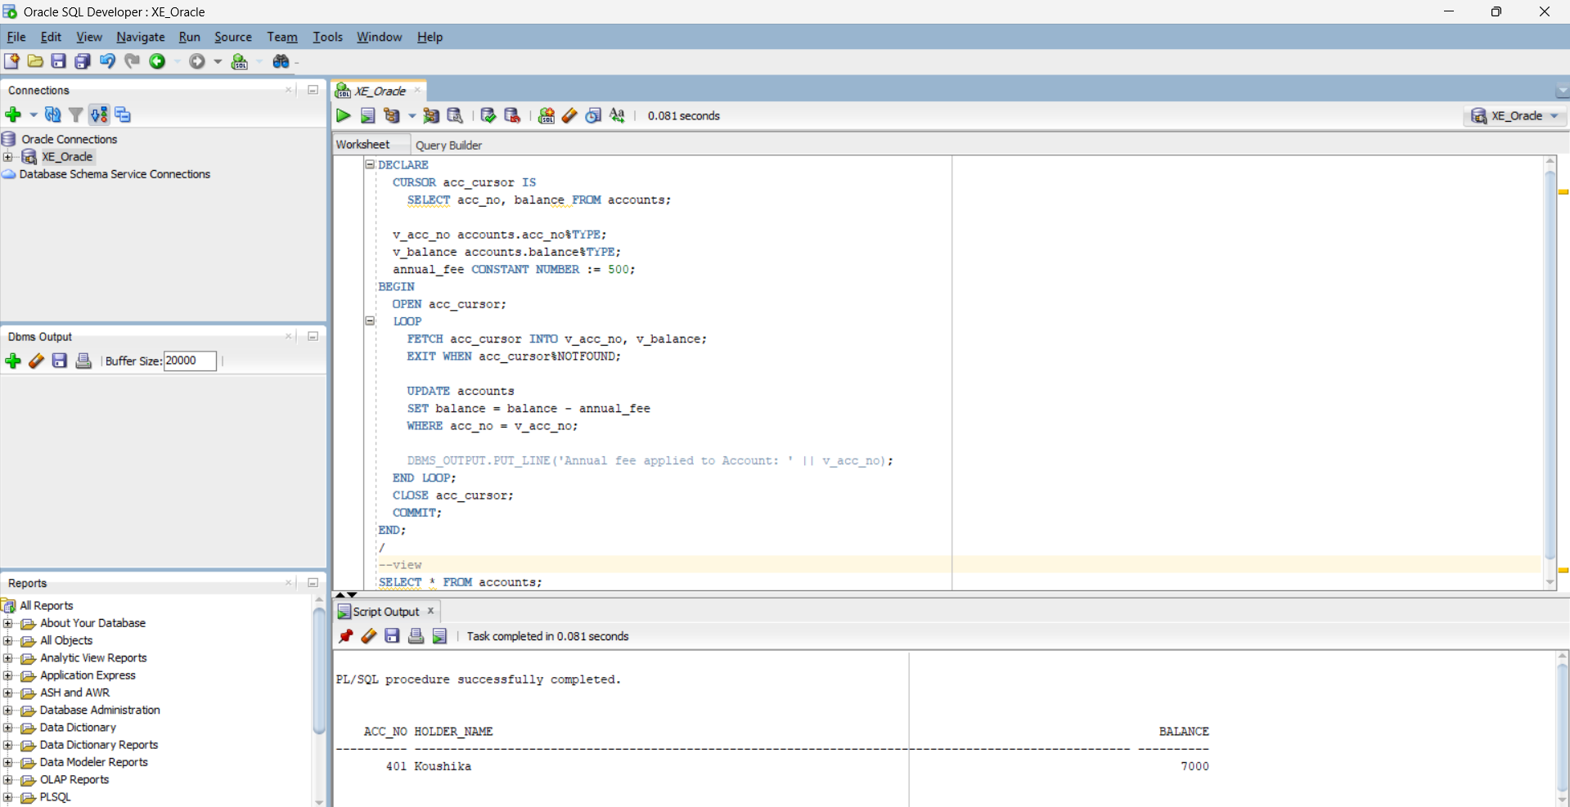
Scenario 3: Update the interest rate for all loans based on a new policy.
Question: Write a PL/SQL block using an explicit cursor UpdateLoanInterestRates that fetches all loans and updates their interest rates based on the new policy.
CREATE TABLE loans (
loan_id NUMBER PRIMARY KEY,
customer_id NUMBER,
interest_rate NUMBER,
due_date DATE
);
INSERT INTO loans VALUES (301, 1, 9.5, SYSDATE + 180);
INSERT INTO loans VALUES (302, 2, 8.0, SYSDATE + 90);
COMMIT;
DECLARE
CURSOR loan_cursor IS
SELECT loan_id, interest_rate FROM loans;
v_loan_id loans.loan_id%TYPE;
v_rate loans.interest_rate%TYPE;
BEGIN
OPEN loan_cursor;
LOOP
FETCH loan_cursor INTO v_loan_id, v_rate;
EXIT WHEN loan_cursor%NOTFOUND;
UPDATE loans
SET interest_rate = v_rate + 0.5
WHERE loan_id = v_loan_id;
DBMS_OUTPUT.PUT_LINE('Updated interest for Loan ID: ' || v_loan_id);
END LOOP;
CLOSE loan_cursor;
COMMIT;
END;
/
--view
SELECT * FROM loans;
OUTPUT:
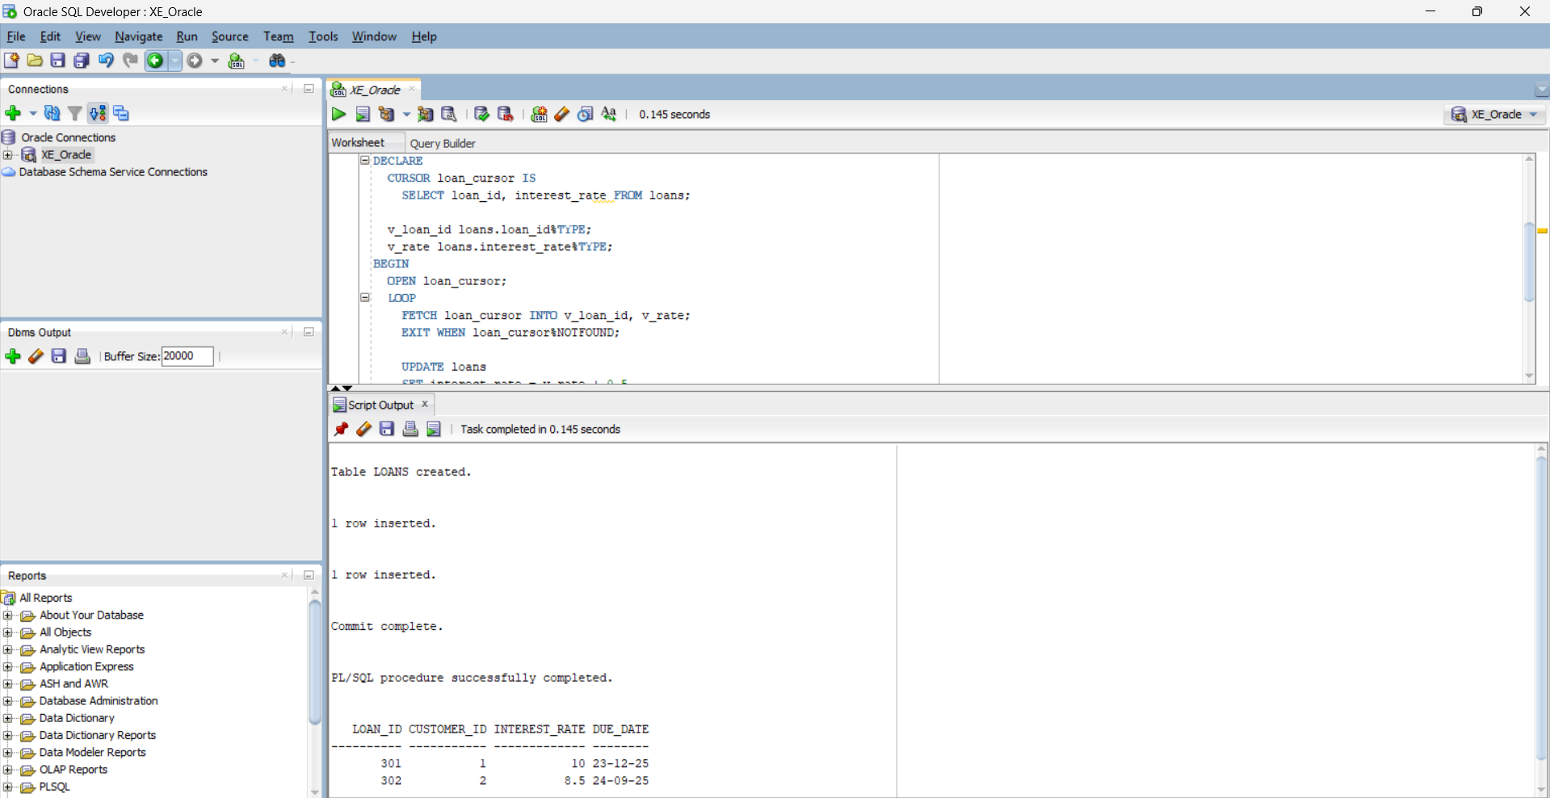

Exercise 7: Packages

Scenario 1: Group all customer-related procedures and functions into a package.
Question: Create a package CustomerManagement with procedures for adding a new customer, updating customer details, and a function to get customer balance.
CREATE TABLE customers (
CustomerID NUMBER PRIMARY KEY,
Name VARCHAR2(100),
DOB DATE,
Balance NUMBER,
LastModified DATE
);
CREATE OR REPLACE PACKAGE CustomerManagement AS
PROCEDURE AddCustomer(p_id NUMBER, p_name VARCHAR2, p_dob DATE, p_balance NUMBER);
PROCEDURE UpdateCustomerBalance(p_id NUMBER, p_new_balance NUMBER);
FUNCTION GetCustomerBalance(p_id NUMBER) RETURN NUMBER;
END CustomerManagement;
/
CREATE OR REPLACE PACKAGE BODY CustomerManagement AS
PROCEDURE AddCustomer(p_id NUMBER, p_name VARCHAR2, p_dob DATE, p_balance NUMBER) IS
BEGIN
INSERT INTO customers (CustomerID, Name, DOB, Balance, LastModified)
VALUES (p_id, p_name, p_dob, p_balance, SYSDATE);
END;
PROCEDURE UpdateCustomerBalance(p_id NUMBER, p_new_balance NUMBER) IS
BEGIN
UPDATE customers
SET Balance = p_new_balance, LastModified = SYSDATE
WHERE CustomerID = p_id;
END;
FUNCTION GetCustomerBalance(p_id NUMBER) RETURN NUMBER IS
v_balance NUMBER;
BEGIN
SELECT Balance INTO v_balance FROM customers WHERE CustomerID = p_id;
RETURN v_balance;
END;
END CustomerManagement;
/
--test
BEGIN
CustomerManagement.AddCustomer(3, 'Koushika', TO_DATE('1999-01-01','YYYY-MM-DD'), 2000);
END;
/

BEGIN
CustomerManagement.UpdateCustomerBalance(3, 2500);
END;
/

DECLARE
v_bal NUMBER;
BEGIN
v_bal := CustomerManagement.GetCustomerBalance(3);
DBMS_OUTPUT.PUT_LINE('Customer 3 Balance: ' || v_bal);
END;
/
OUTPUT:

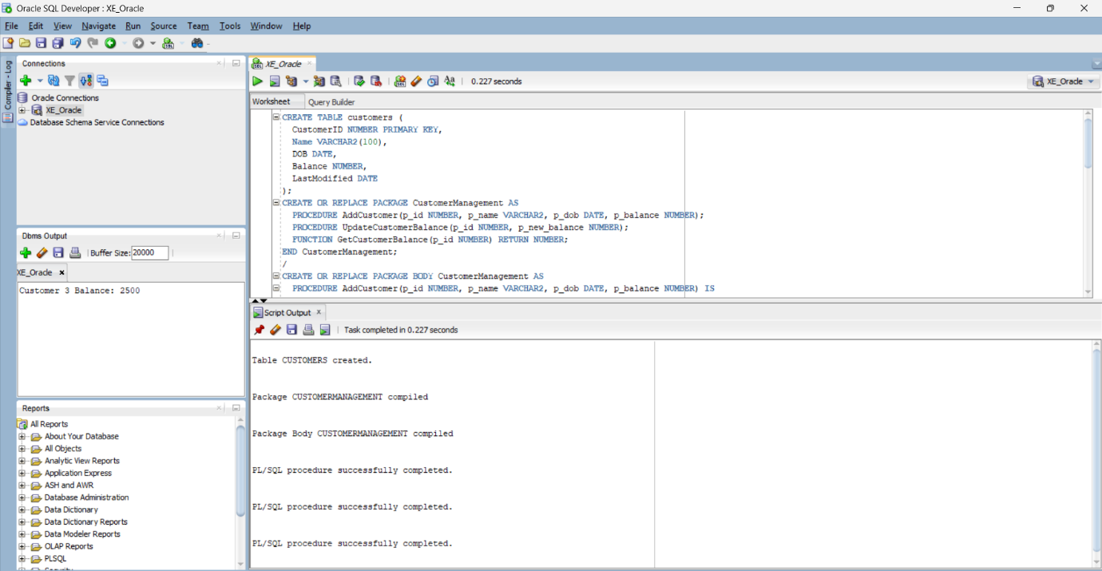

Scenario 2: Create a package to manage employee data.
Question: Write a package EmployeeManagement with procedures to hire new employees, update employee details, and a function to calculate annual salary.
SET SERVEROUTPUT ON;
BEGIN
EXECUTE IMMEDIATE 'DROP TABLE employees CASCADE CONSTRAINTS';
EXCEPTION
WHEN OTHERS THEN
IF SQLCODE != -942 THEN
RAISE;
END IF;
END;
/

CREATE TABLE employees (
EmployeeID NUMBER PRIMARY KEY,
Name VARCHAR2(100),
Position VARCHAR2(50),
Salary NUMBER,
Department VARCHAR2(50),
HireDate DATE
);
/

CREATE OR REPLACE PACKAGE EmployeeManagement AS
PROCEDURE HireEmployee(
p_id NUMBER, p_name VARCHAR2, p_position VARCHAR2,
p_salary NUMBER, p_department VARCHAR2, p_hiredate DATE
);

PROCEDURE UpdateEmployeeSalary(p_id NUMBER, p_new_salary NUMBER);

FUNCTION GetAnnualSalary(p_id NUMBER) RETURN NUMBER;
END EmployeeManagement;
/

CREATE OR REPLACE PACKAGE BODY EmployeeManagement AS
PROCEDURE HireEmployee(
p_id NUMBER, p_name VARCHAR2, p_position VARCHAR2,
p_salary NUMBER, p_department VARCHAR2, p_hiredate DATE
) IS
BEGIN
INSERT INTO employees (EmployeeID, Name, Position, Salary, Department, HireDate)
VALUES (p_id, p_name, p_position, p_salary, p_department, p_hiredate);
END;
PROCEDURE UpdateEmployeeSalary(p_id NUMBER, p_new_salary NUMBER) IS
BEGIN
UPDATE employees
SET Salary = p_new_salary
WHERE EmployeeID = p_id;
END;
FUNCTION GetAnnualSalary(p_id NUMBER) RETURN NUMBER IS
v_salary NUMBER;
BEGIN
SELECT Salary INTO v_salary FROM employees WHERE EmployeeID = p_id;
RETURN v_salary * 12;
END;

END EmployeeManagement;
/

BEGIN
EmployeeManagement.HireEmployee(
3, 'Siva', 'Analyst', 55000, 'Finance', SYSDATE
);
END;
/

DECLARE
v_annual NUMBER;
BEGIN
v_annual := EmployeeManagement.GetAnnualSalary(3);
DBMS_OUTPUT.PUT_LINE('Annual Salary: ' || v_annual);
END;
/

OUTPUT:
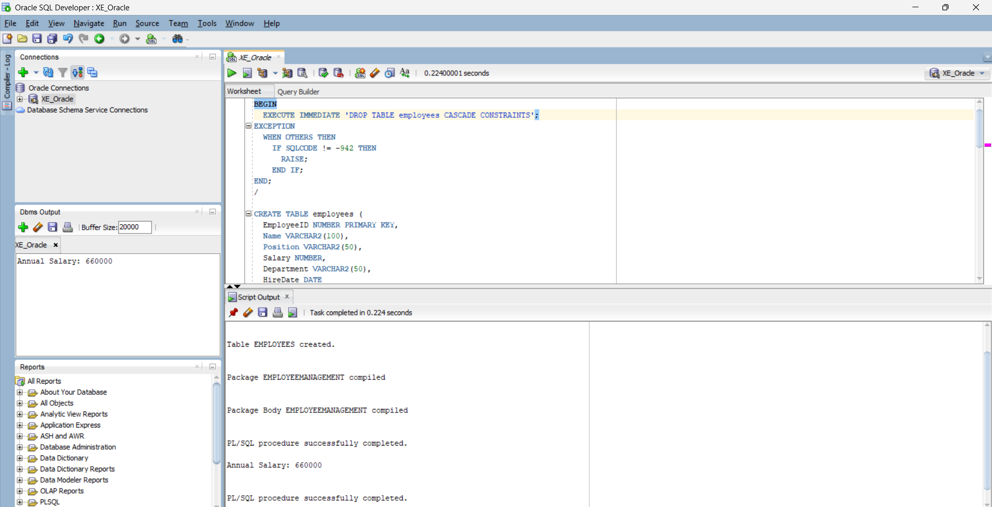

Scenario 3: Group all account-related operations into a package.
Question: Create a package AccountOperations with procedures for opening a new account, closing an account, and a function to get the total balance of a customer across all accounts.
SET SERVEROUTPUT ON;
BEGIN
EXECUTE IMMEDIATE 'DROP TABLE accounts CASCADE CONSTRAINTS';
EXCEPTION
WHEN OTHERS THEN
IF SQLCODE != -942 THEN
RAISE;
END IF;
END;
/

CREATE TABLE accounts (
AccountID NUMBER PRIMARY KEY,
CustomerID NUMBER,
AccountType VARCHAR2(20),
Balance NUMBER,
LastModified DATE
);
/

CREATE OR REPLACE PACKAGE AccountOperations AS
PROCEDURE OpenAccount(p_accID NUMBER, p_custID NUMBER, p_type VARCHAR2, p_balance NUMBER);
PROCEDURE CloseAccount(p_accID NUMBER);
FUNCTION GetTotalBalance(p_custID NUMBER) RETURN NUMBER;
END AccountOperations;
/

CREATE OR REPLACE PACKAGE BODY AccountOperations AS
PROCEDURE OpenAccount(p_accID NUMBER, p_custID NUMBER, p_type VARCHAR2, p_balance NUMBER) IS
BEGIN
INSERT INTO accounts(AccountID, CustomerID, AccountType, Balance, LastModified)
VALUES (p_accID, p_custID, p_type, p_balance, SYSDATE);
END;
PROCEDURE CloseAccount(p_accID NUMBER) IS
BEGIN
DELETE FROM accounts WHERE AccountID = p_accID;
END;

FUNCTION GetTotalBalance(p_custID NUMBER) RETURN NUMBER IS
v_total NUMBER := 0;
BEGIN
SELECT NVL(SUM(Balance), 0) INTO v_total
FROM accounts
WHERE CustomerID = p_custID;
RETURN v_total;
END;

END AccountOperations;
/
BEGIN
AccountOperations.OpenAccount(101, 1, 'Savings', 2500);
AccountOperations.OpenAccount(102, 1, 'Checking', 1500);
END;
/

DECLARE
v_balance NUMBER;
BEGIN
v_balance := AccountOperations.GetTotalBalance(1);
DBMS_OUTPUT.PUT_LINE('Total Balance for Customer 1: ' || v_balance);
END;
/

BEGIN
AccountOperations.CloseAccount(102);
END;
/
DECLARE
v_balance NUMBER;
BEGIN
v_balance := AccountOperations.GetTotalBalance(1);
DBMS_OUTPUT.PUT_LINE('Balance after closing one account: ' || v_balance);
END;
/
OUTPUT:

